Lab5

MIMO Capacity

Exercises

Task 1. Symmetric case.

During task 1 system was reproduced and missing lines of code were added:

[U Dec_H V] = svd(H); % decompose the matrix

xt_tild = V*xt; % pre processing; x is actually transmitted

yt_tild = H*xt_tild + w; % MIMO propagation

yt = U'*yt_tild; % post processing; we're interested in yt

1. SNR:($σ_{n}^{2}$ = 0.01), *nr=nt=4*

With high SNR ($σ_{n}^{2}$ = 0.01) there is almost no difference between $\tilde{x}$ and $\tilde{y}$. Data from all 4 channels is transmitted correctly.

1. SNR:($σ_{n}^{2}$ = 0.5), *nr=nt=4, L=10000*

Ber is calculated as: *Results = sum(xb∼=yb,2)./L*

Obtained Results vector is *[0 0 0,0033 0,2841].* Thus, with lower SNR reliability of some channels decreasing. (Depends on lambda) As singular values are given in descending order. The most unreliable channel will always be the last one.

Task 2. Assymetric case. (nT ≷ nR)

In any assymetric case number of equivalent channels equal to N = min(nT,nR) (N – size of matrix H).

1. [nT , nR] = [5, 3]

In this case only 3 from 5 data flows are participate in transmittion. Anyway, signals are transmitted from all 5 antennas.

1. [nT , nR] = [3, 5].

In this case on the transmittion side y_tilda has 5 channels with information (as number of antennas is 5). But only three channels contain information. Thus two last channels can be cut.

Task 3

Completed skript:

for a=1:length(ant)

disp(['Calculating the ',num2str(ant(a)),'x',num2str(ant(a)),'scenario']);

for r=1:length(ebn0)

Ca=0;

for k=1:nInst

H=sqrt(1/2)*(randn(ant(a),ant(a))+1i*randn(ant(a),ant(a)));

[U S V] = svd(H);

Int = eye(ant(a));

Ca = Ca + log2(det(Int+ebn0(r)/ant(a)*S^2));

end

C(a,r)=Ca/nInst;

end

end

Symmetric case. Achievable capacity is:

$$C=E\left[\log_{2}(I_{nt}+S^{2}\frac{SNR}{nt})\right],$$

where S contains only diagonal entries, which are the ordered singular values of matrix H.

Capacity dependance of SNR for 3 different cases 2 × 2, 3 × 3, and 4 × 4.

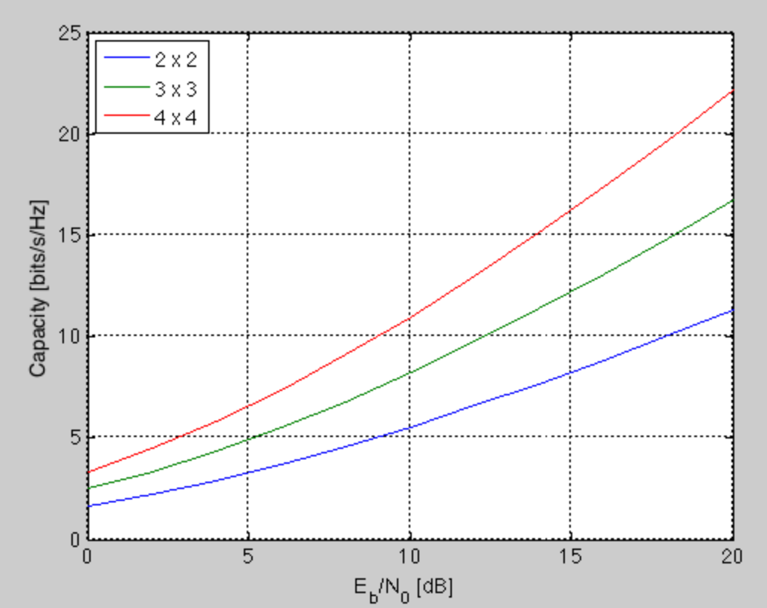

As the number of antennas increases, capacity is increasing.